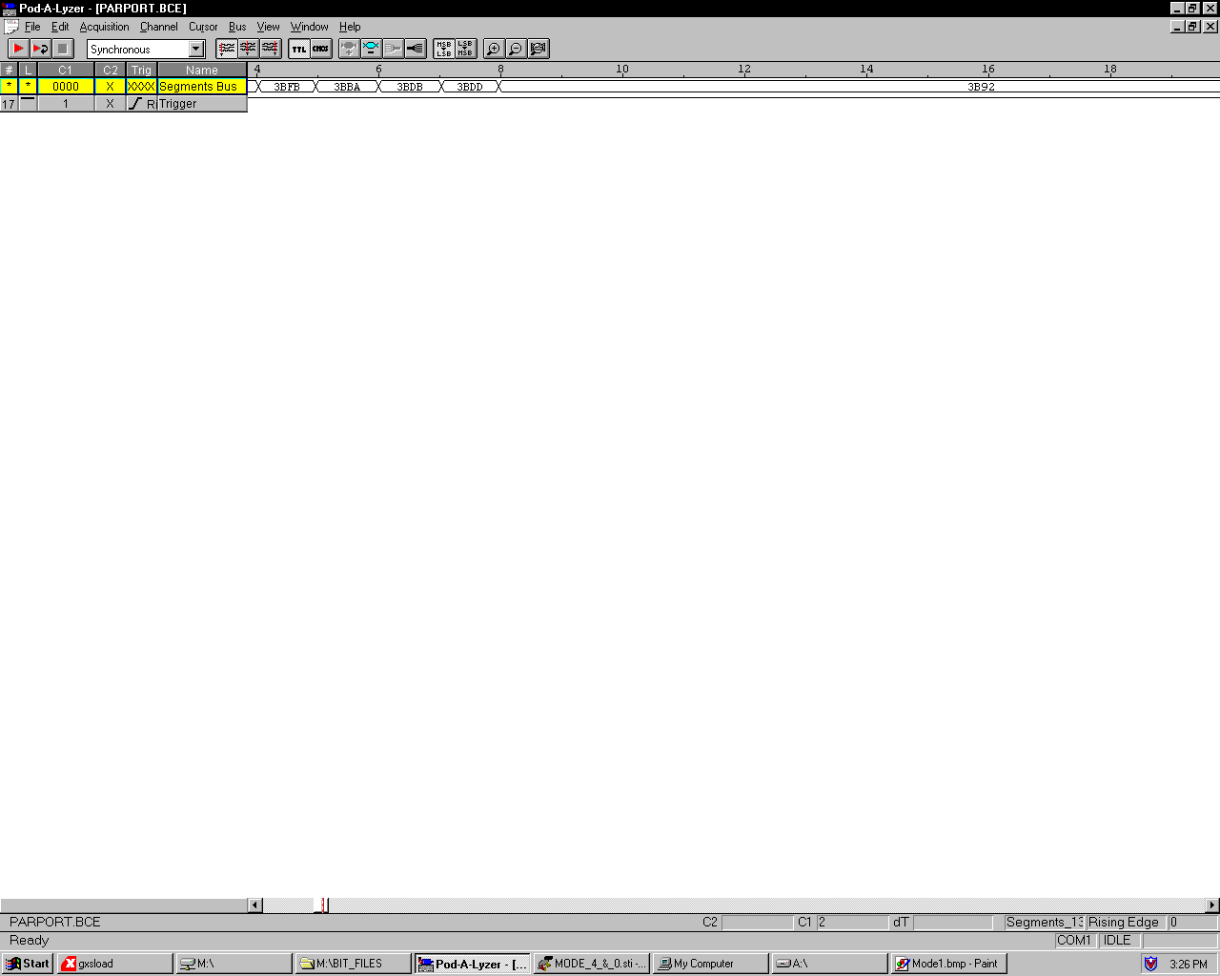
Mode 0

Mode 4

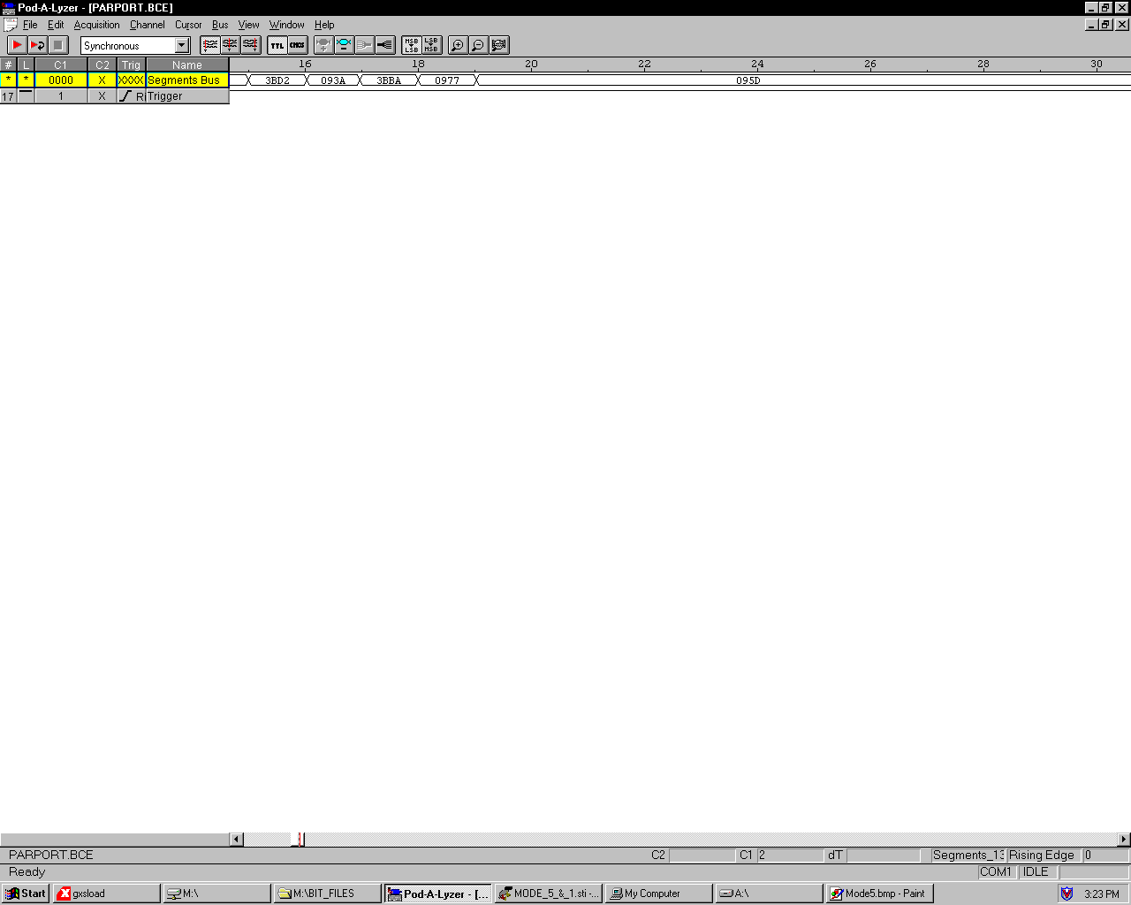
Mode 1

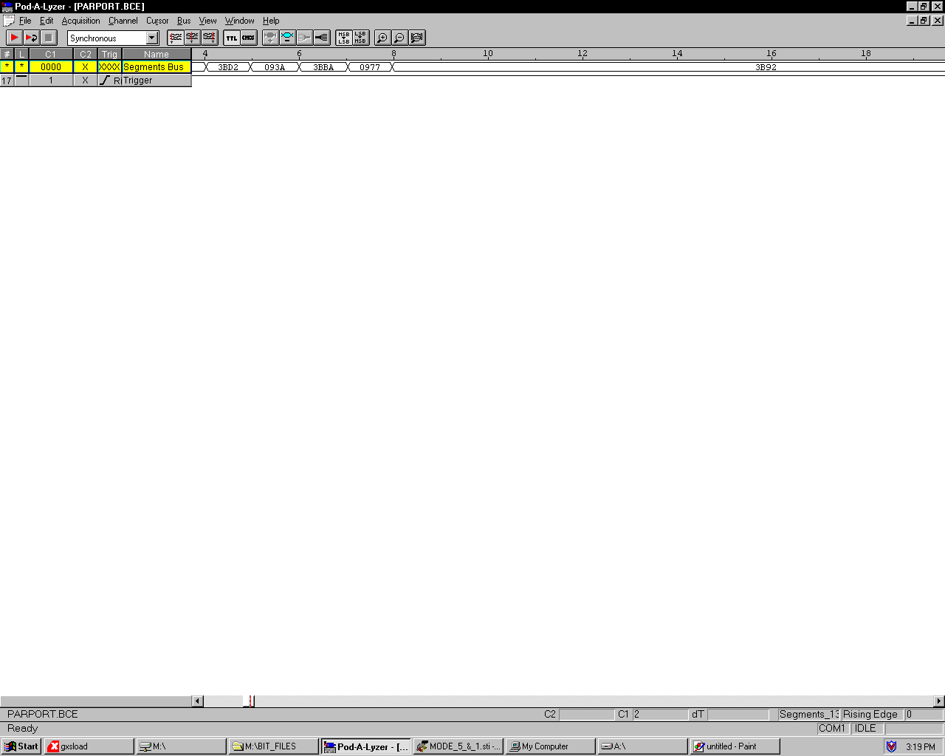
Mode 5

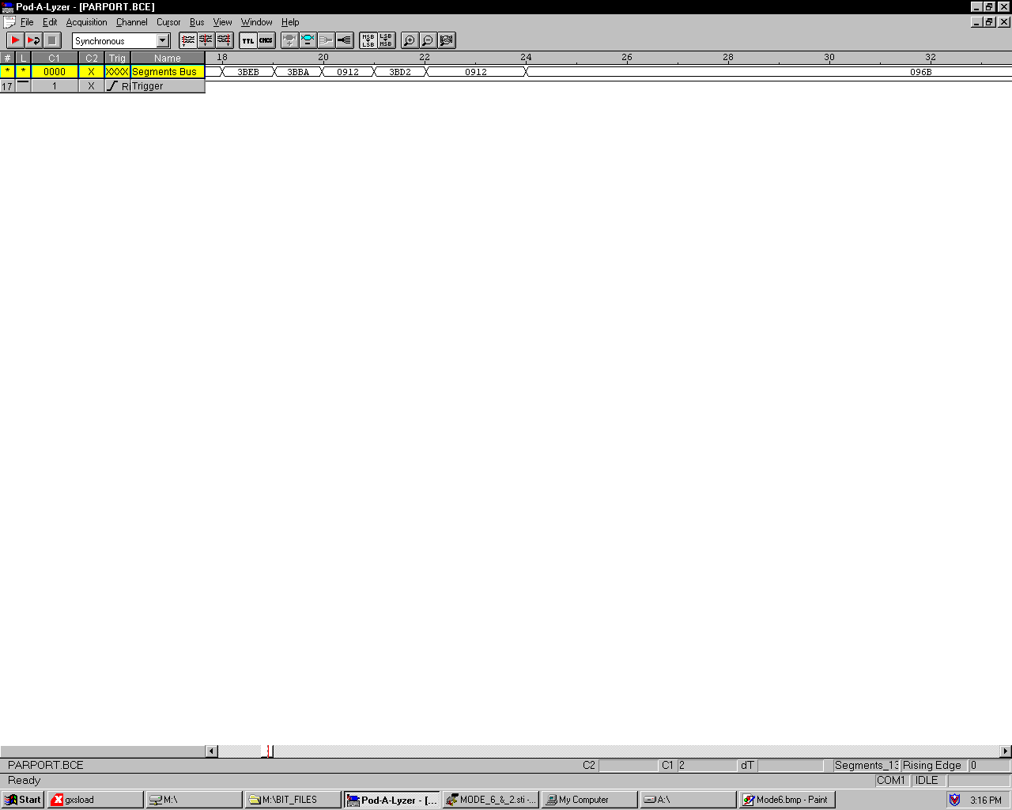
Mode 2

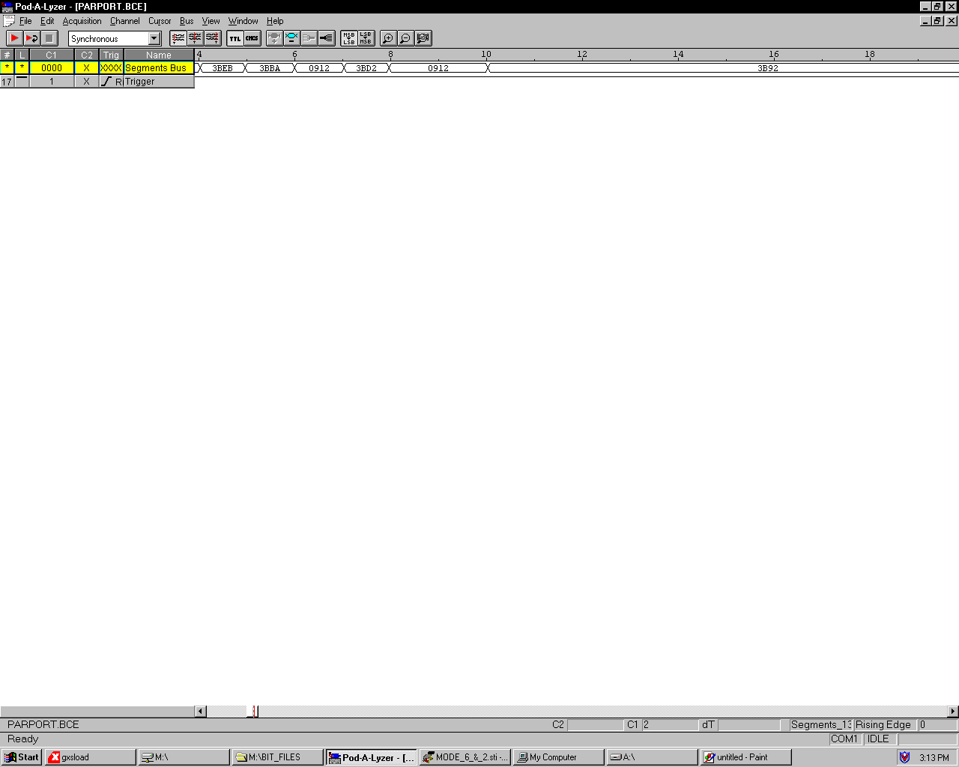
Mode 6

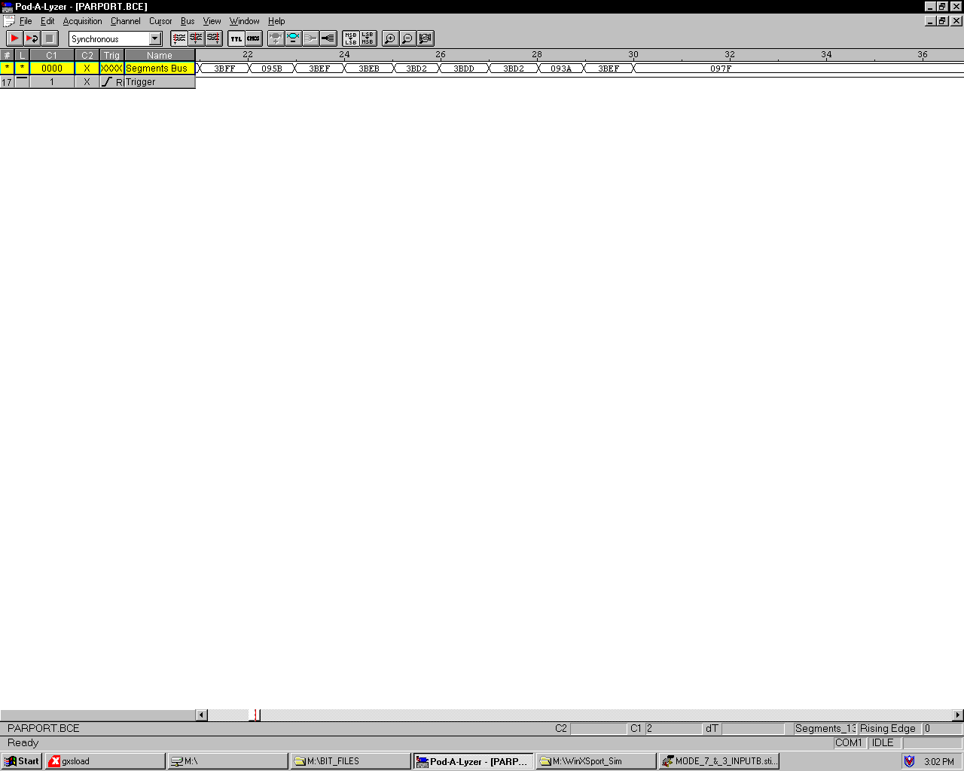
Mode 3

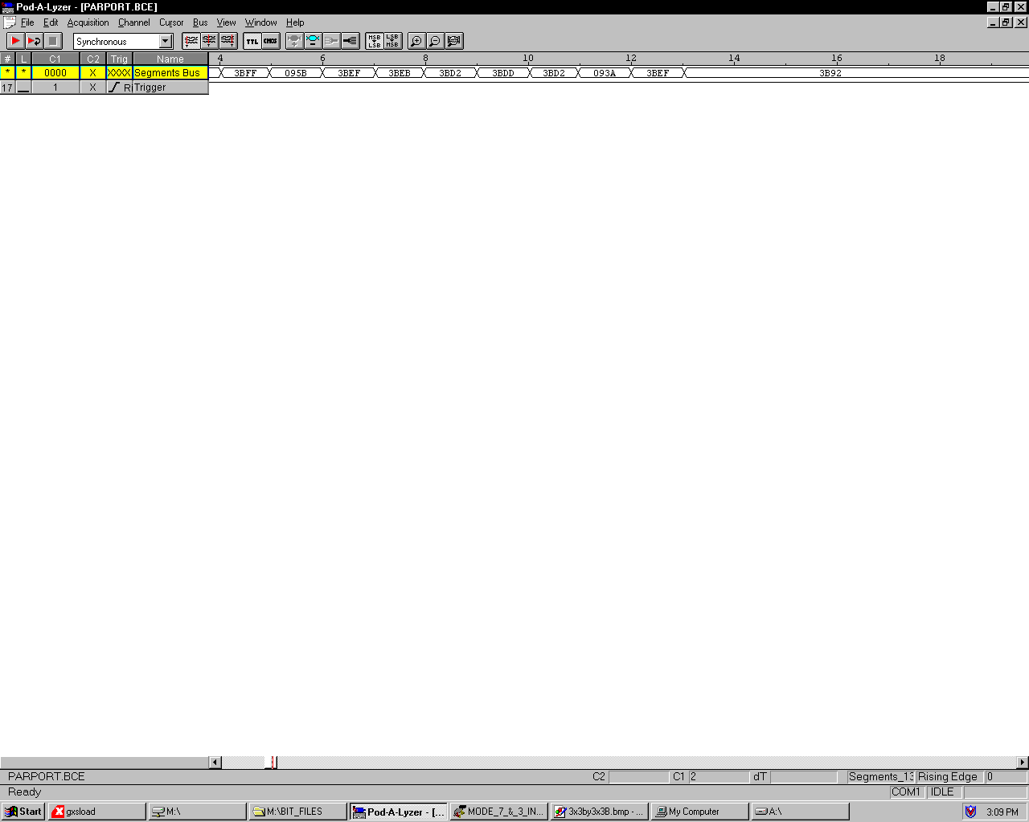
Mode 7

Converting Matrix Multiplier Output Code back into Decimal

Seven Segment Display Hex Code | Number Decimal
3FFF | 0
3B92 | 1
3BDD | 2
3BDB | 3
3BBA | 4
3BEB | 5
3BEF | 6
3BD2 | 7
3BFF | 8
3BFB | 9
0977 | 10
0912 | 11
095D | 12
095B | 13
093A | 14
096B | 15
096F | 16
0952 | 17
097F | 18
097B | 19
2EF7 | 20
2E92 | 21
---- | 22
---- | 23
2EBA | 24
---- | 25
---- | 26
2ED2 | 27
Input data

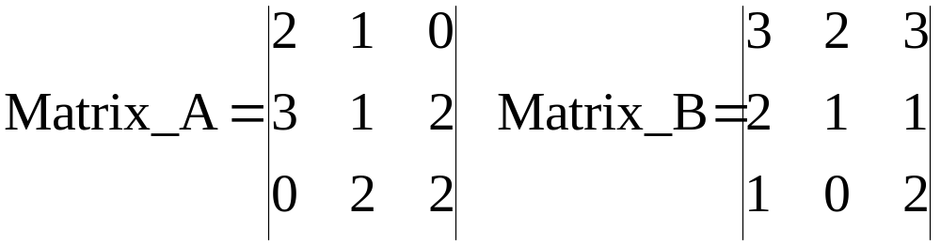 (3x3) by a (3x3) result is a 3x3

Input data

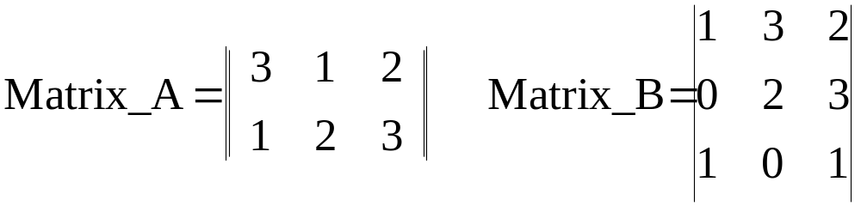 (2x3) by a (3x3) result is a 2x3

Input data

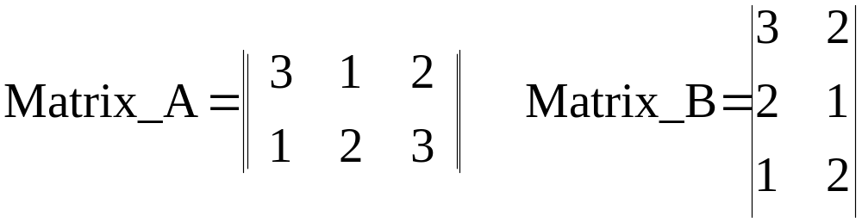 (2x3) by a (3x2) result is a 2x2

Input data

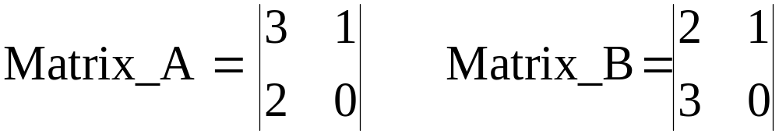 (2x2) by a (2x2) result is a 2x2

Example - Multiplication of 2, 3x3 matrices

27 multiplications, 9 additions

(2 x 3) + (1 x 2) + (0 x 1) = 8
(3 x 3) + (2 x 2) + (1 x 1) = 14
(1 x 3) + (3 x 2) + (2 x 1) = 11
(2 x 3) + (1 x 2) + (0 x 1) = 8
(3 x 3) + (2 x 2) + (1 x 1) = 14
(1 x 3) + (3 x 2) + (2 x 1) = 11
(2 x 0) + (1 x 1) + (0 x 3) = 1
(3 x 0) + (2 x 1) + (1 x 3) = 5
(1 x 0) + (3 x 1) + (2 x 3) = 9

